BIRLA INSTITUTE OF TECHNOLOGY AND SCIENCE, PILANI
SECOND SEMESTER 2016 – 2017
MULTI CRITERIA ANALYSIS IN ENGINEERING (MID SEMESTER EXAMINATION)

Course No: CE G516 Date: 11-03-2017 (Saturday)

Duration: 90 Mins. (4:00-5:30 PM) Max. Marks: 25

Q1. Fuzzy variables A, B, C, and D are represented as following: [4 M]
Fuzzy variable A = [0/0, 0.6/10, 1/20, 0.6/30, 0/40]
Fuzzy variable B = [0/20, 0.6/30, 1/40, 0.6/50, 0/60]
Fuzzy variable C = [0/50, 0.6/60, 1/70, 0.6/80, 0/90]
Fuzzy variable D = [0/100, 0.6/110, 1/120, 0.6/130, 0/140]

A traffic system along a flyover is described by set of two disjunctive rules, using the above fuzzy variables which are as follows:

1. IF fuzzy set A AND fuzzy set B, THEN fuzzy set C
2. IF fuzzy set A OR fuzzy set B, THEN fuzzy set D

Determine the output of the system by graphical implication of MAMDANI using max-min inference if A = 30 and B = 40. Give relevant explanation regarding membership function values of consequents. Use centroid method for defuzzification. Must use graph sheet for approximation.

Q2. An environmentalist studying the impact of Urban development on the Indian rivers has identified six issues namely Restoration of flow (RF), Industrial waste (IW), Sewage waste (SW), Agricultural waste (AW), Open defecation (OD), and Public awareness (PA). These issues are evaluated based on six criteria (C1 to C6) having different weights given on the scale of 0-1. In order to rank the issues based on their criticality, he proposes TOPSIS methodology. Using TOPIS in step by step manner evaluate the following: [5 M]

a. Ideal and Nadir Solution
b. Closeness coefficient and rank the issues

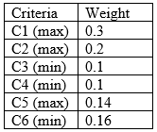 | 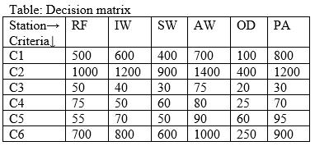

Q3. Define Pareto optimal solution for a minimization case of a multi objective optimization problem using appropriate equation (s). Chittaranjan Locomotive Works is a well-known Railway engines manufacturing company in India which manufactures both for ‘electrical’ and ‘diesel’ engines. The total number of engines that can be manufactures is limited to 5 units each year. Further, the company owner decides to limit the production of electrical engines to 4 units. If ‘x’ is the number of electrical engine units produced and ‘y’ is the number of diesel engines produced, the two objectives planned to be maximized are expressed as

Maximize Z (x, y) = 6x – 4y and Z (x, y) = - 2x + 8y [6]

i. Find the optimal solutions for both the objective functions separately
ii. Generate a neat Pareto Front or non-inferior (efficient) solutions by plotting Decision space and Objective space. Use graph paper. Show all the calculations step wise.
iii. Mention three points that belong to the non- dominated frontier.
iv. Solve the multi-objective problem, for (a) w₁=1 and w₂=2; (b) w₁=2 and w₂=1

Q4. A software company is supposed to rank the worth of a specific computer software in terms of certain criterion. The criteria given by the experts are hardware expandability (C1), hardware maintainability (C2), financing available (C3), and user friendly (C4). The pairwise comparison matrices of four criteria and the alternatives is given below. How do you ensure that the 5 matrices given below are consistent? Justify mathematically. Rank the four software namely A, B, C and D using Analytical Hierarchy Process (AHP) method. RCI values for different values of n are also given. [5]
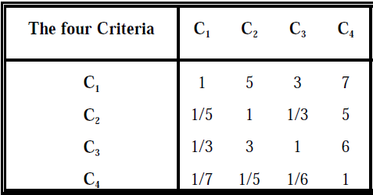
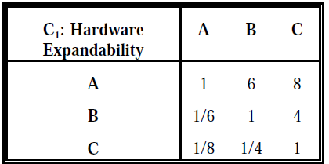 | 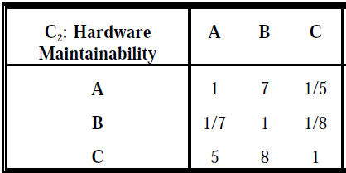
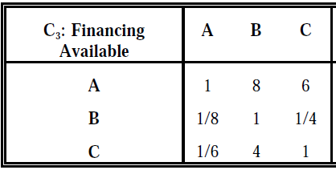 | 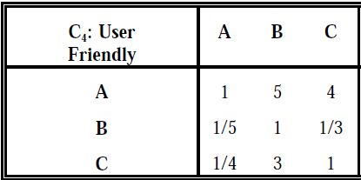

Q5. An ASP produces water for two purposes namely drinking and bathing. For drinking water production four man hours are required and for bathing water production, five man hours are required. Every week 80 man hours are available. The drinking water requires five hours of aeration tank whereas bathing water requires four hours on it. Every week 80 hours are available on aeration tank. The supply of drinking water fetches a profit of Rs. 100 per litres whereas the bathing water supply fetches a profit of 60 per litres. [5 M]
i. Formulate the above problem as linear programming problem
ii. The goals assigned by the decision maker and their priorities are as follows:
Priority goal 1 (P1): A profit target of Rs 1, 400
Priority goal 2 (P2): Minimum of 5 litres of bathing water needs to be produced and supplied
Priority goal 3 (P3): To avoid overtime
Formulate the above program as linear goal programming problem
iii. Represent the optimal solution graphically if and only if goal 1(P1) and goal 2 (P2) is to be satisfied. Shade the feasible region in the graph.

---------------------------------------------------------ALL THE BEST---------------------------------------------------------

